
Islamic Azad University
Tabriz Branch

Faculty of Engineering and Technology
Department of Computer Engineering

Project Report Title:
Documentation for Tire Shop Management Database
Instructor:
Seyyed Sajjad Pirahesh

Prepared by:
Shayan Abdollahi Nami

June 2025

Contents
1. Introduction 3
2. Database Functionality 3
3. Understanding the Environment 4
4. Process Exceptions 5
5. Analysis of Roles and Responsibilities in the System 5
6. Reports 7
7. General System Overview 7
8. Tire Shop Invoice Document 9
9. Extracted Entities 9
10. Tables and Columns 9
11. Database Tables 11
12. Conclusion 18

1. Introduction
This database is designed to address specific challenges and to enable the integrated, improved, and more accurate management of all information related to tire sales and service processes. The primary goal of implementing this system is to create a reliable information infrastructure for storing, retrieving, tracking, and managing data related to customers, their vehicles, inventory of various tire types, the sales process, as well as the stages of providing ancillary services (such as balancing, tire changes, etc.). By utilizing this system, managers and staff can extract detailed analytical and statistical reports and use them to optimize sales strategies, manage warehouse inventory, and make high-level managerial decisions.

2. Database Functionality

This database is designed so that all users, according to their access level, are able to perform the four main CRUD operations—Create, Read, Update, and Delete—on the data. This capability forms the backbone of daily interactions with the system and provides high flexibility for information management.
These operations are manifested in different sections of the system as follows:
- Customer and Vehicle Registration & Management: Creating profiles for new customers, recording information about their vehicles (which can include multiple vehicles for one customer), and updating this information during subsequent visits. This helps in creating a complete history of customer records.
- Sales Order and Service Management: Creating a new order when a customer visits, adding selected tires and required services to that order, and finally issuing an invoice. It is also possible to edit or delete order items before they are finalized.
- Warehouse and Inventory Management: Recording the arrival of newly purchased tires into the warehouse and automatically reducing the warehouse inventory after each sale. This functionality helps prevent the sale of out-of-stock items and facilitates planning for timely purchases.

3. Understanding the Environment
In this operational model, which is based on close collaboration between the manager and the technician, processes are carried out in a compact and multitasking manner. The store manager plays a central role in customer interaction, technical diagnosis, sales, and final management, while the technician is involved in executing services and technical tasks. The process is designed to proceed coherently and efficiently despite the limited number of staff.
When a customer arrives at the shop, the manager personally initiates the reception process. Greeting the customer, he gathers the initial information about the customer and the vehicle and directly enters it into the system. Then, as the senior expert, he personally performs a technical inspection of the vehicle to determine its precise needs (whether it be tire replacement, balancing, or other services). During this time, the technician is typically finishing work on another vehicle or preparing the workshop area for the new one.
After completing the technical inspection, the manager discusses his findings and the associated costs with the customer. Utilizing his expertise, he provides the necessary consultation and, upon receiving final approval from the customer, issues the order to start the work. At this stage, service execution becomes a team effort; the manager oversees critical and specialized tasks, while the technician handles the main technical and operational duties (such as removing and installing wheels, working with machinery, and bringing tires from the warehouse).
At the end of the job, the responsibility for finalizing the process falls again to the manager. He completes the service report in the system, issues the final invoice, and handles the settlement with the customer. Simultaneously, the technician is responsible for the final cleaning, gathering tools, and preparing the vehicle for delivery to the customer. This division of labor in the final stage ensures that the vehicle delivery process is carried out without wasted time and in an orderly manner.
This compact operational structure greatly amplifies the need for a highly efficient and fast information system. The system must be designed so simply and smoothly that the manager can single-handedly and quickly manage all stages of information recording, from customer reception to invoice issuance, while simultaneously maintaining complete oversight of the technician's performance and the overall status of the shop.

4. Process Exceptions
During the execution of the sales and service process, despite careful planning, specific conditions and exceptions may occur that require proper management by the manager and technician. The system must be able to handle these unforeseen events appropriately. The most important of these cases are:
- Customer Cancellation of Services: In some cases, a customer may decide to cancel all or part of their order after initial approval. In this situation, the manager immediately stops the process. If work has been initiated by the technician, the manager calculates any partial costs (if applicable) and handles the settlement process. Furthermore, if a tire or part has been removed from inventory, the manager or technician is responsible for returning it to the warehouse and adjusting the inventory in the system.
- Discovery of New Defects During Service: During work, the technician may encounter a technical issue that was not identified during the initial inspection by the manager (such as a damaged rim or worn wheel studs). In these circumstances, the technician halts the work and informs the manager of the issue. The manager then speaks with the customer, explains the details of the problem and any additional costs, and obtains renewed approval to continue. These matters must be carefully recorded and documented in the customer's order within the system.
- Unavailability of Required Inventory: One of the key challenges is encountering the unavailability of a specific tire after an order has been confirmed. In this case, upon being informed by the manager or technician that the item is out of stock, the process is halted. The manager immediately uses the system to check available alternative options and, by providing technical consultation to the customer, attempts to gain their agreement to select a substitute product. If no agreement is reached, the order may be canceled or put on hold until the item can be procured.

5. Analysis of Roles and Responsibilities in the System
During the process analysis, the tasks and responsibilities of the key personnel working in this shop who will interact with the system were identified. Given the two-person structure, these tasks are divided between the manager and the technician:
- Shop Manager: This role holds complete responsibility for customer communication, sales processes, technical assessment, and overall management. Their main tasks within the system are:
- Reception and Data Entry: Fully explaining the work process to the customer, recording customer and vehicle information (including model and tire size), and creating the initial order in the system.
- Technical Assessment and Final Approval: Technically inspecting the vehicle, accurately diagnosing the required services, providing consultation and pricing to the customer, and obtaining final approval to commence work.
- Financial Management: Issuing the final invoice upon completion of work and recording the financial transaction and settlement in the system.
- Inventory Management: Monitoring inventory levels of goods within the system and making decisions for placing new orders with suppliers.
- Technician: This role is responsible for the complete execution of technical services and workshop tasks. Their duties within the system are more limited and focused:
- Service Execution: Performing all technical services defined in the order (such as tire changes, balancing, etc.) in the sequence specified by the manager.
- Status Reporting: Viewing details of active orders and, if necessary, reporting any problems or new defects observed during work to the manager.
- Inventory Usage: Retrieving required tires and parts from the warehouse based on the information recorded in the order.
In the system design, efforts are made to optimize access levels and the user interface for each role through the precise definition of these two roles. For example, the manager has full access to financial and management reports, while the technician has access to the part of the system needed to view and carry out daily technical tasks. This separation simplifies and streamlines collaboration between the two.

6. Reports
To better manage sales and service processes in the tire shop, the system is capable of generating various reports that can be highly useful for the shop manager. Some of the most important reports are as follows:
6.1. Sales Report for a Specific Time Period
This report shows the financial performance of the shop over a specified period (daily, weekly, or monthly). Information such as the total number of invoices issued, revenue from tire sales, revenue from services, and total overall revenue can be viewed in this report. This report is the most crucial tool for measuring business growth and profitability.
6.2. Inventory and Product Sales Report
This report assists in warehouse management and includes the following:
- Best-Selling Products Report: A list of tires that have had the highest sales, enabling the manager to make more informed decisions for future ordering.
- Low Stock Report: An alert for tiers whose inventory has fallen below a certain threshold, helping to prevent sudden stockouts.

6.3. Customer History Report
This report allows the manager to search by customer name or phone number and access their complete purchase history. This information is highly valuable for offering personalized suggestions and fostering customer loyalty.

7. General System Overview
- Customer arrives at the shop to purchase tires or receive tire-related services.
- The manager records customer and vehicle information, including tire size and requested services.
- The manager performs a technical inspection of the vehicle to provide consultation and finalize the required services.
- The final order is created in the system, including the list of tires and services approved by the customer.
- The technician performs the technical services according to the order registered in the system.
- Finally, the manager prepares the final invoice, and after settlement, the vehicle is delivered to the customer.
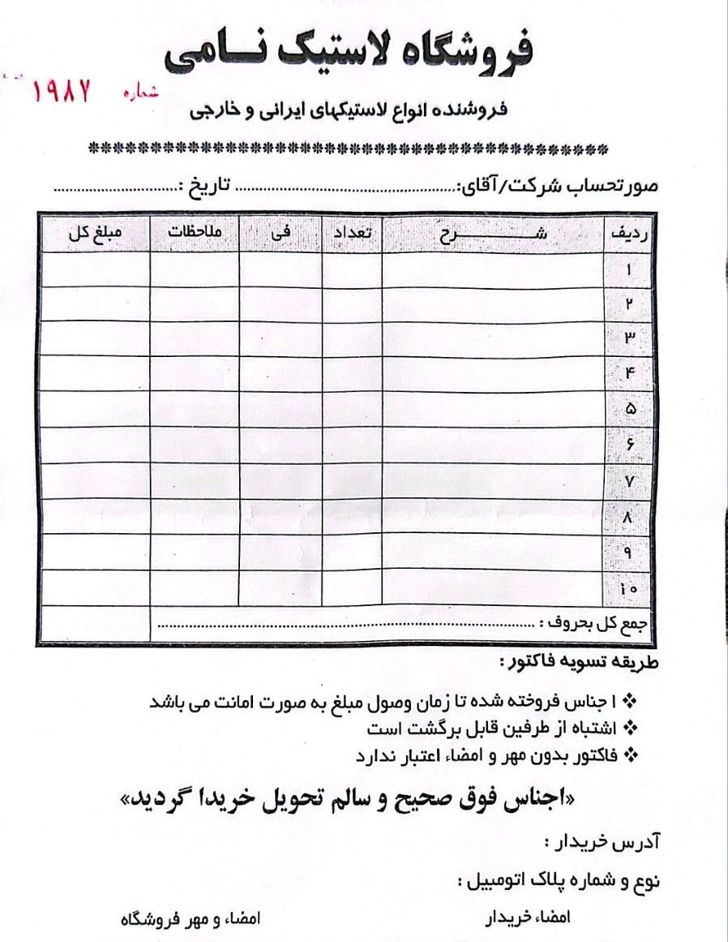

8. Tire Shop Invoice Document
This form is designed as a standard sales invoice for the tire shop and is issued by the seller after providing goods to the customer. The information contained within it includes buyer details, vehicle specifications, transaction date, and a detailed list of sold items along with their quantities and prices.
The information on this form serves as a key document for designing the Invoice, Customer, and Sale entities in a software system. This document acts as the basis for official sales recording, a delivery receipt for the customer, and the shop's financial documentation, gaining validity through signature and stamp.

9. Extracted Entities
1) Customer
2) Tire
3) Size
4) Brand
5) Supplier
6) Service
7) Sales invoice
8) Purchase invoice
9) Invoice items
10) Receipt voucher
11) Payment voucher

10. Tables and Columns
Customer
- customer_id (Primary Key, int)
- full_name (varchar(100))
- phone_number (varchar(20), unique)
- national_code (char(10), unique)
- address (varchar(255))
Brand
- brand_id (Primary Key, int)
- brand_name (varchar(50), unique)
Size
- size_id (Primary Key, int)
- size_name (varchar(50), unique)
Tier
- tier_id (Primary Key, int)
- tier_name (varchar(150))
- stock_quantity (int)
- sale_price (decimal)
- brand_id (Foreign Key, int)
- size_id (Foreign Key, int)
Supplier
- supplier_id (Primary Key, int)
- supplier_name (varchar(100), unique)
- phone_number (varchar(20), nullable)
Service
- service_id (Primary Key, int)
- service_name (varchar(150))
- price (decimal)
Sales_invoice
- sales_invoice_id (Primary Key, int)
- invoice_date (datetime)
- total_amount (decimal)
- customer_id (Foreign Key, int)

Purchase_invoice
- purchase_invoice_id (Primary Key, int)
- invoice_date (datetime)
- total_amount (decimal)
- supplier_id (Foreign Key, int)
Invoice_items
- item_id (Primary Key, int)
- quantity (int)
- unit_price (decimal)
- sales_invoice_id (Foreign Key, int, nullable)
- purchase_invoice_id (Foreign Key, int, nullable)
- tier_id (Foreign Key, int, nullable)
- service_id (Foreign Key, int, nullable)
Receipt_voucher
- receipt_id (Primary Key, int)
- receipt_date (datetime)
- amount (decimal)
- sales_invoice_id (Foreign Key, int)
Payment_voucher
- payment_id (Primary Key, int)
- payment_date (datetime)
- amount (decimal)
- purchase_invoice_id (Foreign Key, int)

11. Database Tables
This database includes various tables, each responsible for storing a portion of the shop's information.
1) Customer (CustomerID, FullName, NationalCode, Address, Phone)
Row | Attribute Name | Attribute Type | Data Type | Nullability | Key | Data Structure | Existence Type | Cardinality
1 | CustomerID | Key | int | Not Null | PK | Simple | Real | Single-Valued
2 | FullName | Simple-Single | nvarchar(50) | Not Null | None | Simple | Real | Single-Valued
3 | NationalCode | Simple-Single | char(10) | Not Null | None | Simple | Real | Single-Valued
4 | Address | Simple-Single | nvarchar(200) | Not Null | None | Composite | Real | Single-Valued
5 | Phone | Simple-Single | char(11) | Not Null | None | Simple | Real | Single-Valued
2) Brand (brand_id ,brand_name)
Row | Attribute Name | Attribute Type | Data Type | Nullability | Key | Data Structure | Existence Type | Cardinality
1 | brand_id | Key | int | Not Null | PK | Simple | Real | Single-Valued
2 | brand_name | Simple-Single | varchar(50) | Not Null | Unique | Simple | Real | Single-Valued

3) Size (size_id ,size_name)
Row | Attribute Name | Attribute Type | Data Type | Nullability | Key | Data Structure | Existence Type | Cardinality
1 | size_id | Key | int | Not Null | PK | Simple | Real | Single-Valued
2 | size_name | Simple-Single | varchar(50) | Not Null | Unique | Simple | Real | Single-Valued

4) Tier (tier_id ,tier_name, stock_quantity, sale_price, purchase_price, brand_id , size_id )

Row | Attribute Name | Attribute Type | Data Type | Nullability | Key | Data Structure | Existence Type | Cardinality
1 | tier_id | Key | int | Not Null | PK | Simple | Real | Single-Valued
2 | tier_name | Simple-Single | varchar(150) | Not Null | None | Simple | Real | Single-Valued
3 | stock_quantity | Simple-Single | int | Not Null | None | Simple | Real | Single-Valued
4 | sale_price | Simple-Single | int | Not Null | None | Simple | Real | Single-Valued
5 | purchase_price | Simple-Single | int | Not Null | None | Simple | Real | Single-Valued
6 | brand_id | Foreign Key | int | Not Null | FK | Simple | Real | Single-Valued
7 | size_id | Forein Key | int | Not Null | FK | Simple | Real | Single-Valued

5) Supplier (supplier_id ,supplier_name, address, phone_number)

Row | Attribute Name | Attribute Type | Data Type | Nullability | Key | Data Structure | Existence Type | Cardinality
1 | supplier_id | Key | int | Not Null | PK | Simple | Real | Single-Valued
2 | supplier_name | Simple-Single | varchar(100) | Not Null | Unique | Simple | Real | Single-Valued
3 | address | Simple-Single | varchar(200) | Null | None | Composite | Real | Single-Valued
4 | phone_number | Simple-Single | varchar(20) | Null | None | Simple | Real | Single-Valued

6) Service (service_id , service_name, price)

Row | Attribute Name | Attribute Type | Data Type | Nullability | Key | Data Structure | Existence Type | Cardinality
1 | service_id | Key | int | Not Null | PK | Simple | Real | Single-Valued
2 | service_name | Simple-Single | varchar(150) | Not Null | None | Simple | Real | Single-Valued
3 | price | Simple-Single | int | Not Null | None | Composite | Real | Single-Valued

7. Sales Invoice (sales_invoice_id , invoice_date, total_amount, customer_id )

Row | Attribute Name | Attribute Type | Data Type | Nullability | Key | Data Structure | Existence Type | Cardinality
1 | sales_invoice_id | Key | int | Not Null | PK | Simple | Real | Single-Valued
2 | invoice_date | Simple-Single | datetime | Not Null | None | Simple | Real | Single-Valued
3 | total_amount | Simple-Single | int | Not Null | None | Simple | Real | Single-Valued
4 | customer_id | Foreign Key | int | Not Null | FK | Simple | Real | Single-Valued

8) Purchase Invoice (purchase_invoice_id , invoice_date, total_amount, supplier_id)

Row | Attribute Name | Attribute Type | Data Type | Nullability | Key | Data Structure | Existence Type | Cardinality
1 | purchase_invoice_id | Key | int | Not Null | PK | Simple | Real | Single-Valued
2 | invoice_date | Simple-Single | datetime | Not Null | None | Simple | Real | Single-Valued
3 | total_amount | Simple-Single | int | Not Null | None | Simple | Real | Single-Valued
4 | supplier_id | Foreign Key | int | Not Null | FK | Simple | Real | Single-Valued

9. Invoice Items (item_id ,quantity, unit_price, sales_invoice_id, purchase_invoice_id, tier_id, service_id )

Row | Attribute Name | Attribute Type | Data Type | Nullability | Key | Data Structure | Existence Type | Cardinality
1 | item_id | Key | int | Not Null | PK | Simple | Relational | Single-Valued
2 | quantity | Simple-Single | int | Not Null | None | Simple | Relational | Single-Valued
3 | unit_price | Foreign Key | int | Not Null | None | Simple | Relational | Single-Valued
4 | sales_invoice_id | Foreign Key | int | Nullable | FK | Simple | Relational | Single-Valued
5 | purchase_invoice_id | Foreign Key | int | Nullable | FK | Simple | Relational | Single-Valued
6 | tier_id | Foreign Key | int | Not Null | FK | Simple | Relational | Single-Valued
7 | service_id | Forein Key | int | Nullable | FK | Simple | Relational | Single-Valued

10) Receipt Voucher (receipt_id, receipt_date, amount, sales_invoice_id)

Row | Attribute Name | Attribute Type | Data Type | Nullability | Key | Data Structure | Existence Type | Cardinality
1 | receipt_id | Key | int | Not Null | PK | Simple | Real | Single-Valued
2 | receipt_date | Simple-Single | datetime | Not Null | None | Simple | Real | Single-Valued
3 | amount | Simple-Single | int | Not Null | None | Simple | Real | Single-Valued
4 | sales_invoice_id | Foreign Key | int | Not Null | FK | Simple | Real | Single-Valued

11) Payment Voucher (payment_id ,payment_date, amount, purchase_invoice_id )

Row | Attribute Name | Attribute Type | Data Type | Nullability | Key | Data Structure | Existence Type | Cardinality
1 | payment_id | Key | int | Not Null | PK | Simple | Real | Single-Valued
2 | payment_date | Simple-Single | datetime | Not Null | None | Simple | Real | Single-Valued
3 | amount | Simple-Single | int | Not Null | None | Simple | Real | Single-Valued
4 | purchase_invoice_id | Foreign Key | int | Not Null | FK | Simple | Real | Single-Valued

12) SalesInvoice_ServiceItems (salesinvoice_id , service_id ,quantity, unit_price )

Row | Column Name | Data Type | PK | Nullable | Unique | FK | Description
1 | salesinvoice_id | int | Yes | No | No | Yes | Foreign key to the sales invoice table
2 | service_id | int | Yes | No | No | Yes | Foreign key to the services table
3 | quantity | int | No | No | No | No | Quantity or amount of service (e.g., 2 hours)
4 | unit_price | int | No | No | No | No | Unit price of the service at the time of sale

13) SalesInvoice_TireItems (salesinvoice_id , tire_id , quantity, unit_price )

Row | Column Name | Data Type | PK | Nullable | Unique | FK | Description
1 | salesinvoice_id | int | Yes | No | No | Yes | Foreign key to the sales invoice table
2 | tire_id | int | Yes | No | No | Yes | Foreign key to the tires table
3 | quantity | int | No | No | No | No | Quantity of tires sold
4 | unit_price | int | No | No | No | No | Unit price of the tire at the time of sale

14) PurchaseInvoice_TireItems( purchaseinvoice_id ,tire_id, quantity, unit_cost )
Row | Column Name | Data Type | PK | Nullable | Unique | FK | Description
1 | salesinvoice_id | int | Yes | No | No | Yes | Foreign key to the purchase invoice table
2 | service_id | int | Yes | No | No | Yes | Foreign key to the tires table
3 | quantity | int | No | No | No | No | Quantity of tires purchased
4 | unit_price | int | No | No | No | No | Unit purchase price of the tire

First Entity | Second Entity | Relationship Type | Relationship Description
Customer | Sales Invoice | 1:N | Each customer can have multiple sales invoices
Sales Invoice | Invoice Items | 1:N | Each sales invoice consists of multiple items (products or services)
Invoice Items | Tire | Generalization/Specialization (U-Type) | If the item type is "Tire", details are stored in the Tire table
Invoice Items | Service | Generalization/Specialization (U-Type) | If the item type is "Service", details are recorded in the Service table
Supplier | Purchase Invoice | 1:N | Each supplier can have multiple purchase invoices
Purchase Invoice | Invoice Items | 1:N | Each purchase invoice includes multiple purchased items
Brand | Tire | 1:N | Each brand can manufacture multiple tires
Size | Tire | 1:N | Each size can apply to multiple tires
Sales Invoice | Service | M:N | Each invoice can include multiple services, and each service can be recorded on multiple invoices
Sales Invoice | Tire | M:N | Each invoice can include multiple tires, and vice versa
Purchase Invoice | Tire | M:N | Each purchase invoice can include multiple tires, and vice versa
Sales Invoice | Receipt Document | 1:N | Each sales invoice can be settled with multiple receipt documents
Purchase Invoice | Payment Document | 1:N | Each purchase invoice can be settled with multiple payment documents

12. Conclusion
This document provided an overview of the process of analyzing and designing a database structure for a tire shop, along with its core functionalities. By carefully examining the workflows of a two-person shop, an efficient database was designed that covers all key entities, from customers and suppliers to product details, invoices, and financial documents. This database provides a suitable tool for storing, managing, and retrieving critical business information.
By precisely defining the attributes of each entity and the final table structures, the groundwork for implementing a successful information system has been established. Utilizing this infrastructure, the primary system user (the shop manager) can easily extract necessary reports and queries (such as monthly sales reports or inventory by brand) and quickly obtain the information needed for informed decision-making.
Ultimately, this design, by providing a digital infrastructure, helps reduce human errors, increase productivity, and improve business management. It also establishes the necessary readiness for subsequent development phases, including designing software forms and implementing the system's core functionalities (CRUD).

